**Name: Mohammad Sami Zaman; ID: 21201207; SEC: 04; LAB01**

Create the above table with appropriate data type for each column.

Create table developers (member_id int, name char(30), email varchar(50), influence_count int, Joining_date date, multiplier int);

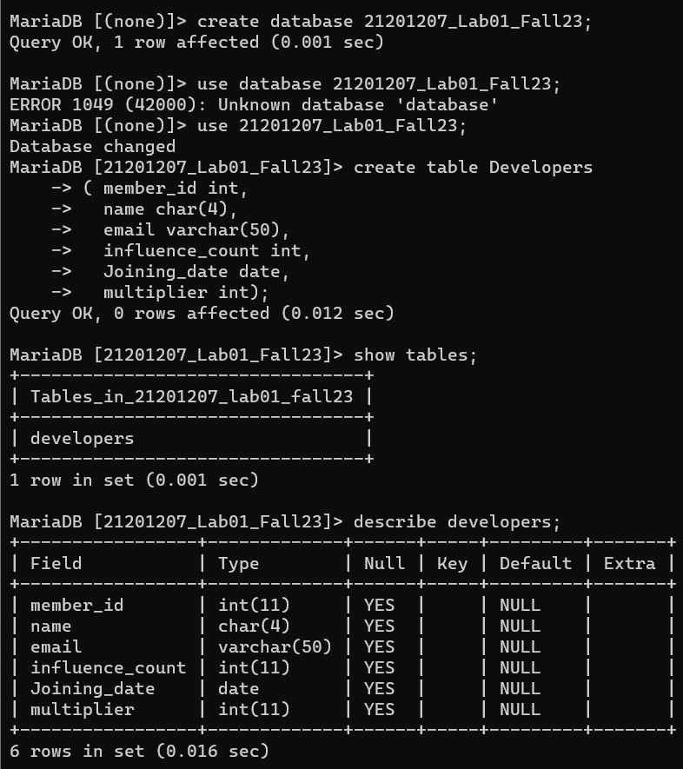

Inserting all data into the table by using

Insert into developers values (member_id, name, email, influence_cou, Joining date, multiplier);

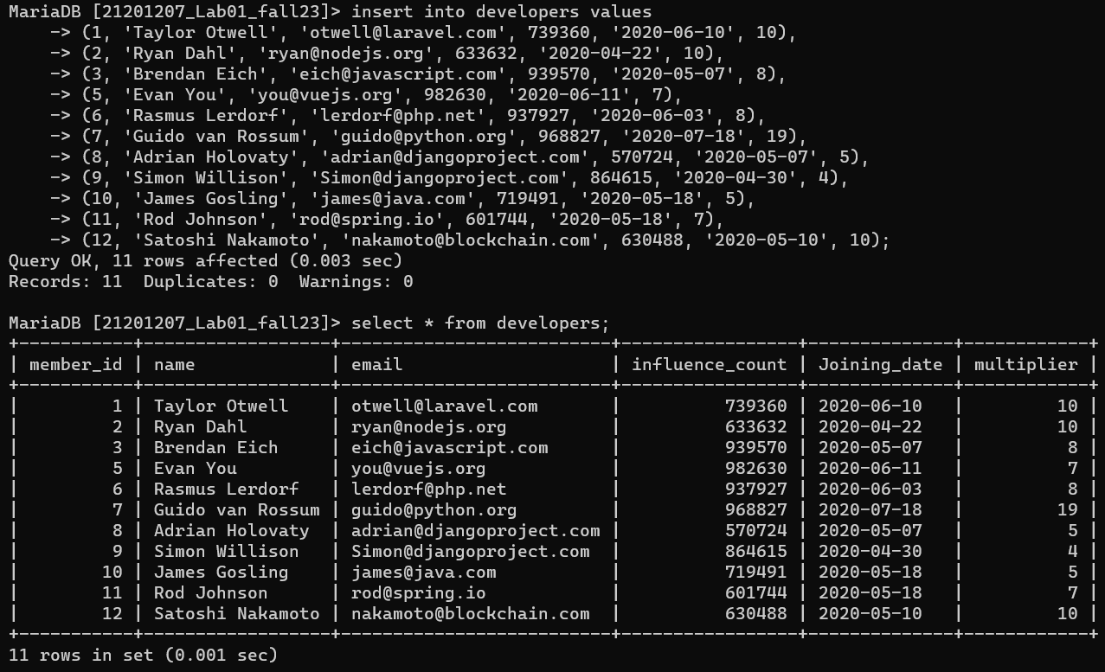

2. Change the column name “influence_count”. The new name should be “followers” and the data type should be integer.

Alter table developers change influence_count followers int;

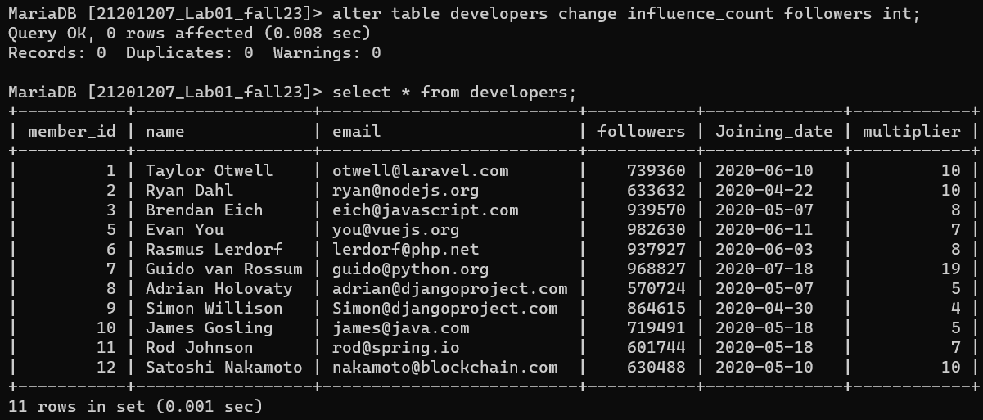

3. Update the number of followers of each developer by +10.

Update developers set followers = followers + 10 where member_id < 13;

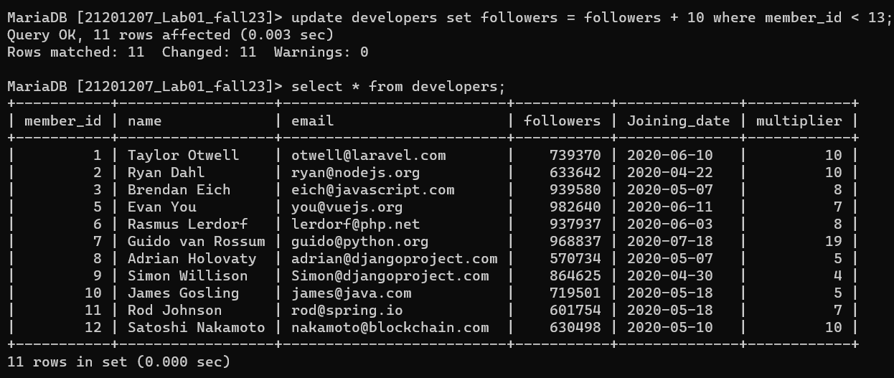

4. There is a formula to find the efficiency of the developers. Efficiency = ((followers*100/1000000) * (multipliers*100/20))/100. Show the efficiency of each developer in a column named “Efficiency” along with their name.

Alter table developers add efficiency double;

Update developers set efficiency = ((followers * 100 /1000000) * (multiplier * 100/20))/100 where member_id < 13;

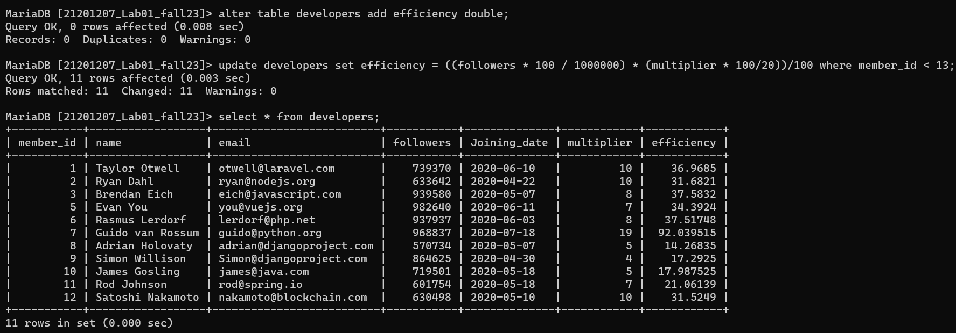

5. Show the name and email of the developers who have the 5 highest numbers of followers.

Select name, email from developers order by followers desc limit 5;

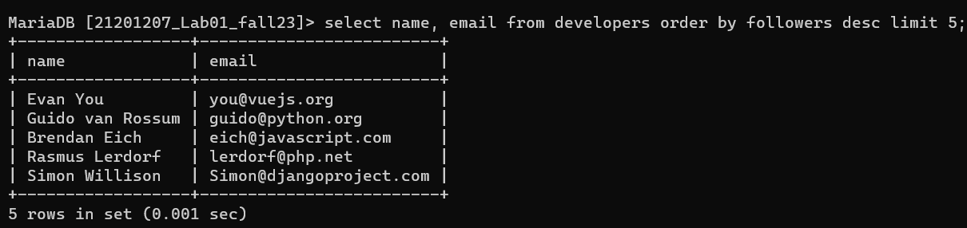

6. Show the name of all users with the maximum multiplier among the developers whose number of followers is less than 700000.

Select name, multiplier from developers where followers < 7000000 and multiplier = (select max(multiplier) from developers where followers < 7000000);

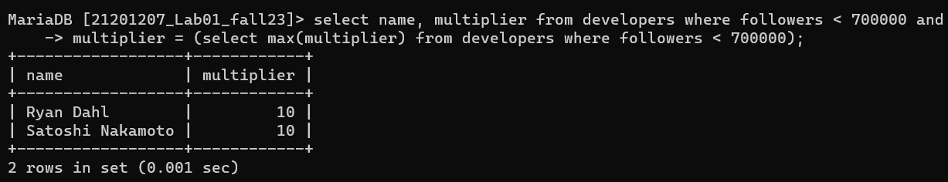

8. Retrieve the member_ id, name, email and followers of the developers who have either “.com” or “.net” in their email address.

Select member_id, name, email, followers from developers where email like ‘%.com’ or email like ’%.net’;

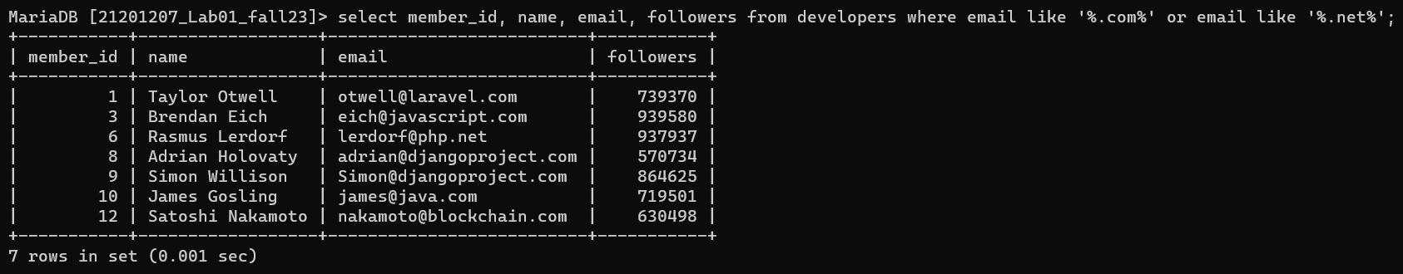

7. Find the average of the number of followers but only consider the members who joined before 11 June 2020.

Select avg(followers) from developers where Joining_date < ‘2020-06-11’;

